­

**Ellucian Banner**

**Account Termination Procedures**

* Account terminations are typically initiated by staff in the Human Resources department as part of off-boarding procedures for departing employees. These requests include both full-time and part-time employees who have previously been granted privileged access to Ellucian Banner.
* HR staff members create a new **Employee Account Management** (EAM) record. A blank EAM record is shown below and identifies the information that HR provides as part of a Cease Access request:

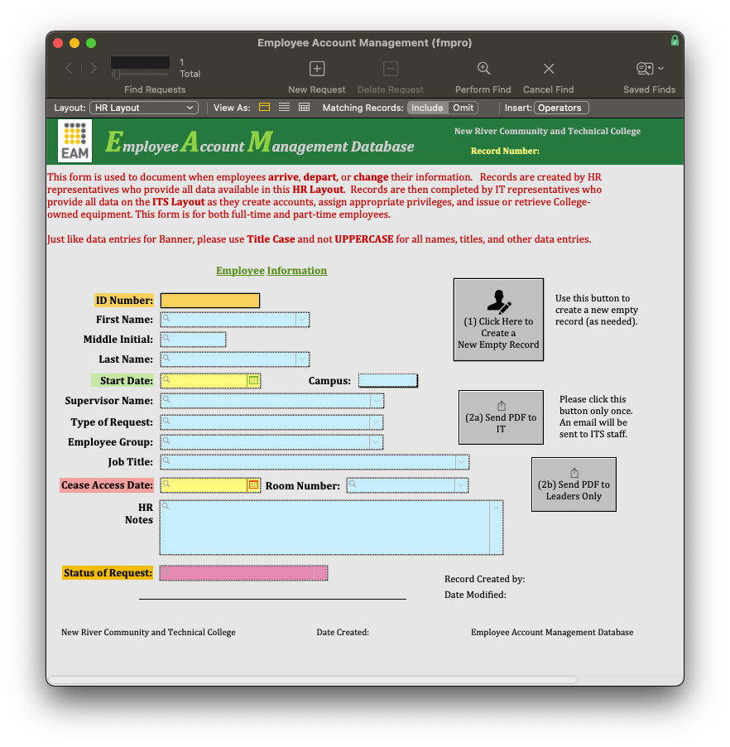

* Supervisors of **work-study** and **temporary employees** are responsible for notifying HR or IT staff members when an employee is no longer working. This notification ensures that off-boarding procedures are initiated to revoke privileged access and recover any equipment that was issued.
* This notice should be provided at least 7 days before the last day of employment.
* IT staff members who support Ellucian Banner generate a report twice a year that enables supervisors of **adjunct faculty** and **advisors** to review access privileges that have been granted. Feedback from this report identifies any accounts that are no longer needed and is sent to the IT staff so that privileges may be revoked.
* IT staff revoke access privileges by expiring and locking accounts, as well as inactivating the New River email address on SPAIDEN, marking SIAINST to denote the employee is no longer active, and disabling access on GOATPAD.
* Accounts are never deleted in Ellucian Banner; instead, they are maintained in an expired and locked status. This enables a returning employee to regain former privileges when needed while providing audit records for use as needed.
* When IT staff complete these steps, they send a copy of the completed EAM record to key personnel as both a notification and a detailed summary of the changes made.